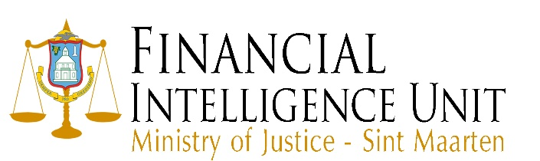

Ultimate Beneficial Owner (UBO)

- According to article 1, paragraph 1, sub z, under ee of the National Ordinance Combatting Money Laundering and Terrorism Financing, the UBO is a natural person who has an interest of more than 25% of the capital, or can exercise more than 25% of the client’s voting rights at a shareholders’ meeting, or in some other way can exercise effective control in or on behalf of the client or a natural person who is the beneficiary of 25% or more of the capital in a legal construction, including a foundation or a trust, or can exercise effective control in the legal construction or has control over 25% or more of a client’s capital.
- If your company has, more than two (2) UBOs you can copy paste a table and continue filling in the details.

UBO 1
First name
Last name
Nationality
Home address
Street, number, area
Country
Zip Code  If applicable. | Click here to enter text.
Profession
Percentage of holding or interest
Type of share
Voting rights attached to share
Amount paid on shares
Additional payment obligation
Date of acquisition of shares
Was share certificate issued
Establishment/transfer of right of usufruct over shares and transmission of voting rights connected
Establishment of a right of pledge on the shares and transmission of voting rights connected

UBO 2
First name
Last name
Nationality
Home address
Street, number, area
Country
Zip Code  If applicable. | Click here to enter text.
Profession
Percentage of holding or interest
Type of share
Voting rights attached to share
Amount paid on shares
Additional payment obligation
Date of acquisition of shares
Was share certificate issued
Establishment/transfer of right of usufruct over shares and transmission of voting rights connected
Establishment of a right of pledge on the shares and transmission of voting rights connected

Please attach for every UBO the following documents:
- A copy of the ID document
- A copy of the share certificate (if issued)

